European Parliament: A knowledge Management portal
Executive summary: The European parliament included Knowledge Management as one of the three pillars of its strategy. Knowledge Management is supported by the implementation of two main tools: Collaborative sites (SharePoint technology) and a Knowledge Management portal. This portal includes a dashboard, connected to external websites, RSS feeds and previous search results, a powerful search engine (accessing both internal database and external websites) and a calendar.
It took more than 4 years between the start of the knowledge programme and the launch of the portal. More than 10 people have been (and still are) involved in the project, which cost probably several millions EUR.
25% of EP staff have connected at least once to the portal and 1 Directorate and one Unit from another Directrate have embedded the use of the portal in their business processes.

Strategy
The EP strategy main objective is that all staff (MEPs, assistants, civil servants) can work anywhere, anytime, with any device. It included three aspects:
- Paperless Parliament, aiming at giving access to the works of the Parliamentary Commissions from anywhere, the capability to hold meetings remotely and to edit documents during meetings.
- eParliament, aiming at increasing the quality and usage of documents (through their .xmlisation), providing the opportunity to submit amendments online, signing electronically and managing administrative, fiscal, financial processes online (for MEPs).
- Knowledge management, aiming at increasing the capacity of analysis and decision making of all staff. It included collaborative sites and a knowledge portal. A competence database was initially in the scope, was withdrawn for political reasons but will finally be added later.
The framework for knowledge management includes the following concepts: One place for everyone, a powerful search engine, collaborative workspaces and EP documents in context.
The knowledge management programme was set up in 2009. In 2010, the main EP documents were manually indexed. In 2011, a KM Governance board and working groups were created. In 2012, the KM portal v1 was released for selected people. In 2013, new functionalities were added and the portal was extended to other user groups. In 2014, the knowledge portal was officially launched during the DG ITEC forum. In parallel, a process for creating collaborative sites has been launched.

Organisation
The EP counts approximately 6,000 staff members spread over 13 DGs, plus 751 MEPs and their assistants.
The knowledge management initiatives are driven by DG ITEC (Innovation & Technology).
In total, up to 12 persons have been involved in the knowledge portal project. One top, staff from other Directorates contributes to the indexation of documents (e.g. in DG COMM: 3 FTEs). Additional external support was provided at the start of the programme.

Collaborative sites
The solution SharePoint has been chosen for the creation of collaborative sites.
The DG ITEC visited every single other DG and identified one champion (called business analyst) in each DG. This business analyst prepares requirements to be implemented by Customer Relationship Manager (CRM) of DG ITEC. Typically, the initiative starts with a pilot for an organisational entity of the DG (not the full DG). In general, DG ITEC offers “Sharepoint as a service”, i.e. a customized, not-editable space where the DG can upload and download documents and create staff profiles (with “My Site”). This service is quick – usually delivered within a week. For more complicated requests, a business case has to be developed by the DG. DG ITEC can help setting up these more complicated websites or the DG could do it itself if it has the right competencies.
During 18 months, an Analysis Committee analysed all requests for the creation of SharePoint sites to avoid anarchy. Currently, the access has been simplified.
To encourage collaborative work, the Secretary General of the EP has requested all DGs to adopt this approach.

Knowledge Portal
The knowledge portal (inspired from Netvibes) includes a dashboard, a search engine and a calendar presented in 3 tabs in the same engine.
The dashboard gives access to 3 types of sources shown in boxes (widgets):
- RSS feeds (news obtained by subscription to external portals)
- Links to external websites (like the “favorites” in a browser)
- Results from the search engine: The parameters of searches remain active, and when a new document meeting the search criteria is uploaded in the platform, it appears in the box.
The dashboard is customizable by each individual user (technology J2E). Each user can create as many dashboards as s/he wished (presented in different tab). A dashboard can also be shared with another person, who can then customize it further to his/ her needs. Finally, a dashboard can be “pushed” by an expert user (e.g. by the directorate staff of a DG) to a group of people – i.e. for example a DG can push its dashboard to all Directorate staff. It is then one dashboard amongst the others created by the staff member.
The search engine access documents in the EP internal databases as well as external websites selected by expert users (up to 6 external databases can be selected by search). The results are shown in a different box for each source. For the EP internal databases, the documents are shown in their context, i.e. for example a draft document of a commission will be shown with the previous and next versions, with the dates of the different changes. The results are linked to the calendar (third tab). However, the different EP internal databases are not consolidated, i.e. the same document can appear several times.
The access to external databases is managed by the Google Search Appliance. The EP pays a licence based on number of searches/ hits. Only public sites are accessible (i.e. not Commission’s intranets for instance).
This dashboard/ search engine is also accessible via tablets, but only in read-only mode.
This single entry point enables a quicker learning curve. It also speeds up the searches and provides more relevant results by putting documents in context.
To encourage a new way of working and promote the use of the portal:
- A link has been added on the front page of the Intranet;
- News have been published on the Intranet;
- Videos have been produced for different types of users (for example, one specifically for interpreters);
- Champions have been identified in each DG;
- An effort has been made to propose a good layout (done by a web designer)
At the moment, 1,500 staff members have connected at least once to the portal. One Directorate (DG INTE (Interpretation)) and one Unit from another Directorate (DG COMM (Communication)) and have embedded the use of the portal in their business processes.
The Parliament invested approximately 500,000 – 1 million EUR per year in that project.

Contacts
Marc Rossi, DG ITEC, Assistant coordinateur d'équipe (marc.rossi@europarl.europa.eu, +352 4300 22839)
Laura Liudvinaviciute, DG ITEC Assistant applications TIC (laura.liudvinaviciute@europarl.europa.eu, +352 4300 25755)

Sources
Presentation delivered by the EP to the Court (Magdalena Cordero, Franck Noël, Andreas Bolkart, Olivier Prigent) on 02/06/2015

Annex: SCREENSHOTS FROM the Knowledge portal
A dashboard view
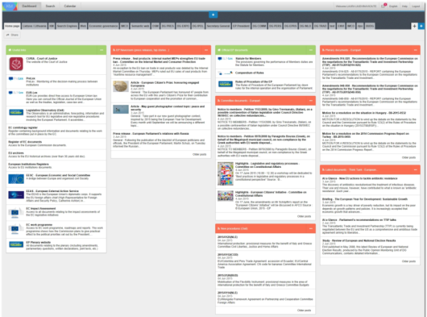
Example of a search results providing contextual data for a document
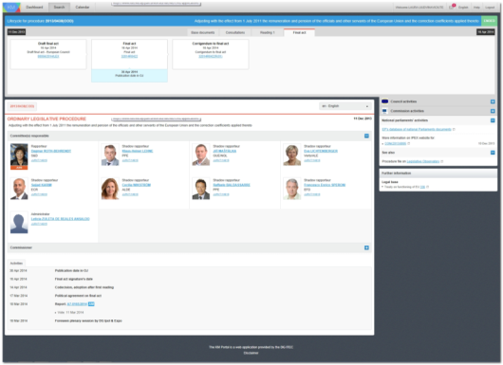

Example of a search results from several sources
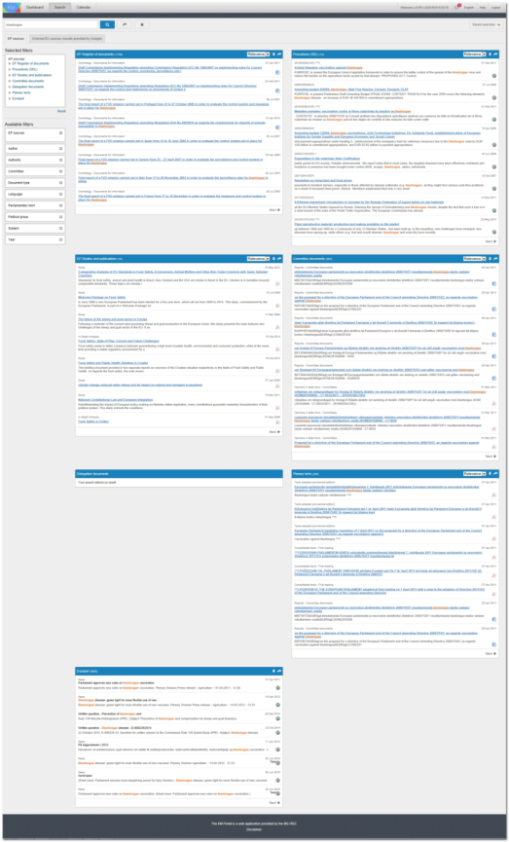

Profiles linked to activities
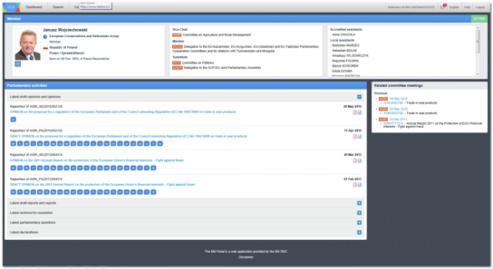
Calendar view
