DG COMP: Wikis and dedicated Knowledge Managers
Executive summary: .DG COMP (similar size as ECA) uses COMP wiki as the main tool for knowledge sharing. Three full-time knowledge managers are responsible for the content. They are supported by “Knowledge Gardeners” in each operational unit who feed them with content. They also receive the support of several technical assistants
The tool Confluence has been chosen to set up the wiki. Overall, it took approximately one year to set up the tool, 1 year to show-case it and 2 years to really get it included in work processes and habits. Since the launch of the tool, the number of visits has increased by 15-20% per year.
The support of the Director General and the buy-in of middle-managers were key in implementing this tool.

Strategy
DG COMP did not prepare a specific strategy about Knowledge management. As an IT HoU involved at the start of the project put it, “delivery was the strategy”.
In 2012, the deputy Director General requested IT to make proposals about the way the DG was managing knowledge, to support both newcomers and experienced staff.
IT first identified the main sources of knowledge (Manuals of business processes, legal background such as main regulations and case law and lessons-learned from previous similar cases). It also assessed that the work of case-handlers would be enhanced if handled “multi-laterally” and not just “bi-laterally”, such as in a wiki. As a result, IT tested with users three wiki solutions: SharePoint, Mediawiki and Confluence. SharePoint was considered as very complex and too sophisticated. Confluence, put at the disposal of DGs for “free” by DIGIT (which supports 100% of the licence fees) was assessed as more user-friendly than Mediawiki (open source).
Once the IT solution was selected, the structure of the wiki was quickly set up. It took more time to feed the wiki with content (see 3 Processes). The structure was then reviewed later when more content was available.
Overall, it took approximately one year to set up the tool (with the support of 2 x 20 days of an external consultant and an internal graphic designer), 1 year to show-case it and 2 years to really get it included in work processes and habits.

Organisation
DG DEVCO counts approximately 850 staff members, spread in 7 Directorates.
Three full-time dedicated Knowledge Managers are spread in operational units (“case handling”), in different directorates, to cover the three main instruments (Anti-trust and cartels, mergers, State aids). They were selected as former case-handlers for their knowledge of the needs of the main business processes. They work in a Steering Committee led by three Heads of Units. They receive the support of several technical assistants, including a full-time Information and Communication Assistant - Knowledge management assistant (Unit Communications Policy and interinstitutional relations) and from two dedicated librarians for research on request (Unit Document management, which includes 47 staff members).
On top, they are fed by information (important new developments, various news, databases) and questions from about 35”Knowledge Gardeners” spread in each operational unit of DG COMP (one per unit).

Processes
The main tool used to share knowledge is a wiki database called COMP wiki. It started to be implemented in 2012. At the beginning, several case handlers were detached for rotations of six months as “Knowledge Managers” to set up and feed the tool. However, while they were supposed to be 100% dedicated to knowledge management, they were still handling their former cases. They fed the tool with contributions, which made it look too much as a simple repository, not easily searchable. They felt that a six-month rotation was not sufficient to step back and build an effective tool. As a result, three permanent positions of Knowledge Managers have been created.
This Knowledge Management team spent considerable time thinking about the best ways to make the wiki database user-friendly and easy to search. They adopted a common structure but slightly customized it to the needs of each main domain (Anti-trust and cartels, mergers, State aids) since users have different needs and habits.

IT infrastructure
COMP wiki is based on the tool Confluence. It was considered more user-friendly than Mediawiki and simpler than SharePoint. It meets the needs of DG COMP even if it is not well adapted for co-authoring, even if several people can work on the same page.
A dedicated internal website has been created with strict firewalls because of the high confidentiality of data managed. Pages have been created for each instrument and each sector. Manual of procedures and legal bases are also included.
Anybody can edit the pages (except for example the manuals of procedures), but usually, because of lack of time, the Knowledge gardeners send useful material to the Knowledge Managers who edit and upload it in a structured way. Anybody can comment the content and organise it according to their needs with widgets. Users can receive alerts when new content matching their preference is published.
Content is frequently updated, but not necessarily every day. Actually, one of the most consulted parts is the legal provisions – The content is not necessarily “new” but it is maintained up-to-date.
The main complaints received about the tool concern the search engine, not as powerful as a “Google”. Because the content is quite technical, it requires some manual search. The Knowledge management team knows well the structure of the wikis and can support users to find the relevant content if their search with the search tool is unsuccessful.
Since the launch of the tool, the number of visits has increased by 15-20% per year.

Culture/ Change management process
COMP wiki received a strong support from the Director General. He helped to get the buy-in from all managers, some of whom were initially reluctant to share information. The involvement of the Director General also helped to provide recognition to contributors.
The creation of three permanent Knowledge Management positions, in a context of reduction of staff especially in the support services, was a strong signal. On top of these three full-time positions, the knowledge gardeners have, according to their job descriptions, to dedicate a part of their time to knowledge sharing.
To encourage staff to contribute, the Knowledge management team tries to make the tool as user-friendly as possible. It also provided some concrete incentives (e.g. bottles of champagne for best contributors) and included knowledge sharing via COMP wiki in work procedures.
One of the main incentives for staff to contribute, according to a recent survey, is “recognition”. Some colleagues are reluctant to contribute on a wiki by fear of writing something wrong.

Contacts
DG COMP
- Vera POZZATO, Case Handler - 'Knowledge Manager' (Vera.POZZATO@ec.europa.eu, 90617)
- Alexandrina TOLAN, Information and Communication Assistant – Knowledge management assistant (Alexandrina.TOLAN@ec.europa.eu, 58710)

DIGIT (staff involved in the development of COMP wiki)
- Isabelle KRAUSS, Head of Unit - Head of IT Governance and Communication Unit (Isabelle.Krauss@ec.europa.eu, 66929)
- Lucia FRANCKX-SOLDATOVA, Information and Communication Assistant (lucia.franckx-soldatova@ec.europa.eu, 99717)

Sources
Welcome page of the wiki (screenshot)
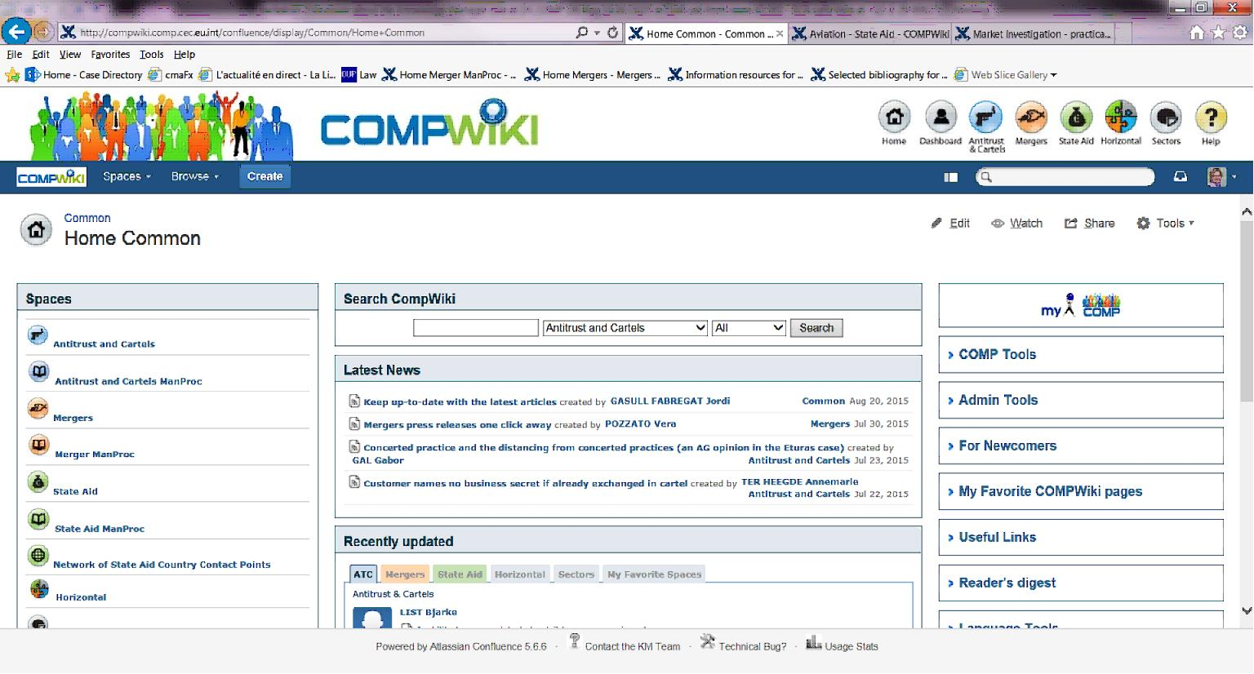
DG COMP wiki project

